Partnership mapping tool
(Adapted from The Health Foundation, 2017)
This tool can help you tailor your communication strategies and build stronger partnerships by focusing on the partners with the most significant impact on your project’s success. You might move along a continuum of involvement depending on the project at hand and depth of involvement. Partners should be able to decide how and when they would like to be engaged in implementation. The International Association for Public Participation (n.d.) describes the following levels of engagement:
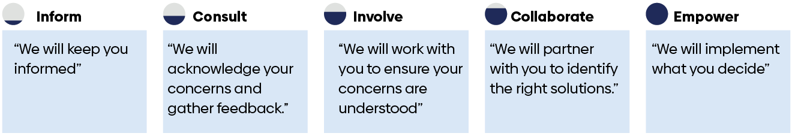
In the grid, one axis represents partners’ relative level of influence, and the other axis represents their level of interest or involvement. Place partners in different quadrants, such as high influence-high interest, high influence-low interest, so you can prioritize your engagement efforts. Higher influence partners with a strong interest can be engaged closely (collaborate in regular meetings or include on your team). In comparison, lower influence partners might require less attention (keep them informed through newsletters and website updates).
- Identify all partners who may have a role in your project. Think about including partners:
  - Within your organization. Include people from different departments or teams that can contribute expertise or resources.
  - Within your community. Community organizations like nonprofits, government, or local businesses might provide valuable insights, resources, and connections.
  - Across the system. Partnering with organizations from different sectors, like public and private groups and funders, can bring diverse perspectives and resources.
You can also consult current regional demographic data, like age, gender, ethnicity, income, and education levels, to ensure equitable representation from partners.
  - Ask: Is there anyone else who should be included in this work?
- Consider to what degree each partner can contribute or might be willing to engage with your project.
- Place all your listed partners on the grid in the appropriate quadrant.
- Based on which quadrant your partners are listed in, plan how you will engage and communicate with them.
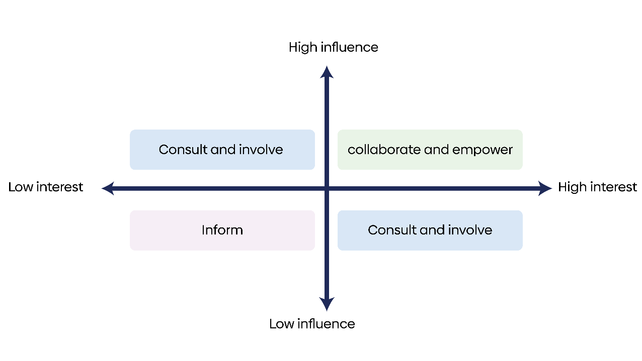
List of all partners:
- _________________
- _________________
- _________________
- _________________
- _________________

References
International Association for Public Participation. (n.d.). IAP2 spectrum.
The Health Foundation. (2017). Q community CAPS toolkit.

